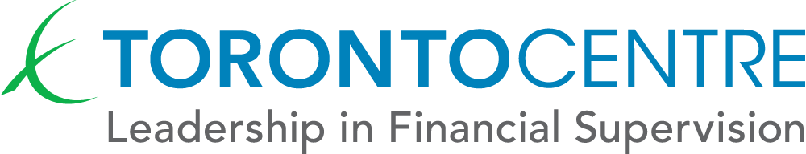
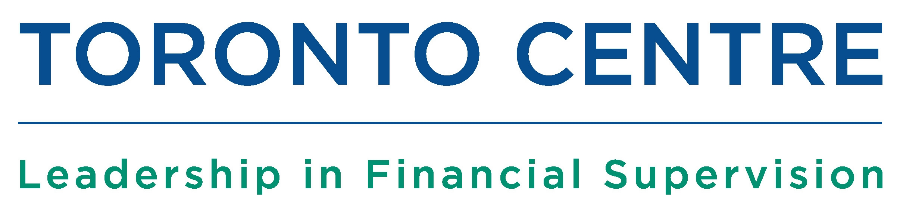

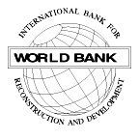



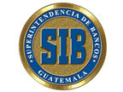

CRISIS PREPAREDNESS PROGRAM

Guatemala - October 11 - 14, 2011
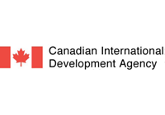
CRISIS PREPAREDNESS PROGRAM

Guatemala, October 11 – 14, 2011

Hosted by: Superintendencia de Bancos, Guatemala
Organized by the Toronto Leadership Centre in partnership with the World Bank

Objectives
The Program is designed to provide participants with the opportunity to practice the roles that monetary policy makers in central banks, supervisory/regulatory authorities and deposit insurance corporations play in managing a cross-border crisis arising from problems in a potentially systemic financial institution. The case studies and computer-simulated exercises will explore how central bankers, supervisors and deposit insurers co-ordinate with each other, and with other authorities internationally, during a crisis.
The crisis simulation exercise is designed to provide participants with the opportunity to practice dealing with some of the challenges of domestic and cross-border coordination in the management of a potentially systemic financial crisis involving cross-border banking groups. This includes the coordination of assessment and decision-making within and between national authorities, and the use of measures that authorities could deploy in a crisis.
In a simulated environment, the participants will be able to (i) practise using processes of contingency planning and dealing with failing banks; (ii) coordinate with supervisors, central banks and deposit insurers and with other authorities nationally and internationally in a crisis; and (iii) deal with systemic consequences of a bank failure. At the end of the Program, participants will be able to examine the critical components of a crisis preparedness/contingency planning guide in accordance to international best practices.

Target Group
The Program is designed for mid to senior level supervisors and regulators with responsibility for managing financial stability, financial surveillance and supervision of banking institutions, and central bankers involved in monetary policy and operations. The program is also highly relevant to staff of deposit insurance corporations. This program will be conducted in Spanish.

Tuesday, October 11th

8:30 – 9:00 OPENING CEREMONY
Group Photograph

9:00 - 10:30 Contingency Planning
Valeria Garcia - World Bank
- The role, importance and benefits of contingency planning
- How to develop contingency plans
- Crisis preparedness resource materials (the crisis binder)
- Inter-agency contingency plans
- Simulating crises to test readiness
- Updating legal powers, resources and crisis planning.

10:30 – 10:45 Tea Break

10:45 – 12:30 Contingency Planning (cont’d)

12:30 – 13:30 Lunch

13:30 – 15:00 Central Bank Instruments for Dealing with Financial Crises
Javier Bolzico, Fit & Proper
- Legal and financial instruments available to central banks during a financial crisis
- Emergency liquidity assistance, open market operations, quantitative easing, collateral requirements, rules and flexibility
- Solvency criteria
- System wide liquidity monitoring
- Meaning and application of systemic risk criteria

15:00 – 15:15 Tea Break

15:15 – 17:00 Central Bank Instruments (cont’d)

Wednesday, October 12th

8:30 – 8:45 Ideas I will use

8:45 – 10:00 Bank Resolution
Javier Bolzico
- Problem institutions and unviable institutions
- Conceptual aspects and alternate structures for bank resolution
- Pros and cons of alternatives
- Considerations in deciding between alternatives
- Principles of bank resolution
- Good Bank – Bad Bank structures
- Systemic and non-systemic cases

10:00 – 10:15 Tea Break

10:15 – 12:30 Bank Resolution (cont’d)

12:30 – 13:30 Lunch

13:30 – 15:00 Systemic Impact Assessment Framework
Aquiles Almansi, World Bank
- Rationale of systemic impact assessments.
- Systemic risk and contagion
- Constituents of a framework to assess systemic risk.
- Implementation challenges

15:00 – 15:15 Tea Break

15:15 – 17:00 Systemic Impact Assessment Framework (cont’d)

17:00 – 17:30 Briefing on Simulation Exercise
Aquiles Almansi, World Bank

Thursday, October 13th

8:30 – 8:45 Ideas I will use

8:45 – 17:30 Cross Border Financial Crisis Simulation Exercise
Aquiles Almansi, World Bank

Friday, October 14th

8:30 – 10:30 Crisis Simulation – Plenary Session Discussion and Debrief
Aquiles Almansi, World Bank

10:30 – 10:45 Tea Break

10:45 – 12:30 Contingency Planning - Brainstorming Session
Valeria Garcia

12:30 – 13:00 CLOSING CEREMONY
Concluding Remarks

